Configure Selenium WebDriver

Now we will configure our Eclipse IDE with Selenium WebDriver. In simple terms, we will create a new Java Project in Eclipse and load all the essential jar files in order to create Selenium Test Scripts.

* Launch Eclipse IDE
* Create a new Java Project from **File > New > Java Project**.

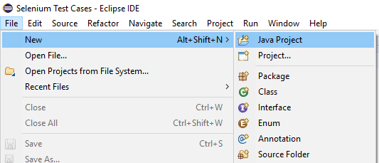

* Give your Project name as "Demo_Test", leave the other fields unaltered and click on "Finish" button.
* It will create a new Java project with the following directories.

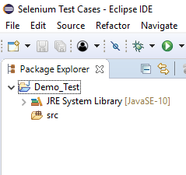

Note: Selenium Test Scripts are always written in ".class" file in Java. Here the project "Demo_Test" act as a Test Suite that may contain one or more Selenium test cases/test scripts.

* Right click on the "src" folder and create a new Class File from **New > Class**.

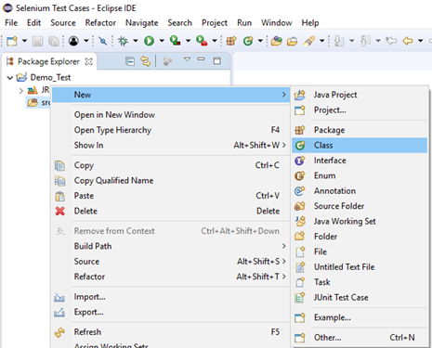

* Give your Class name as "First" and click on "Finish" button.

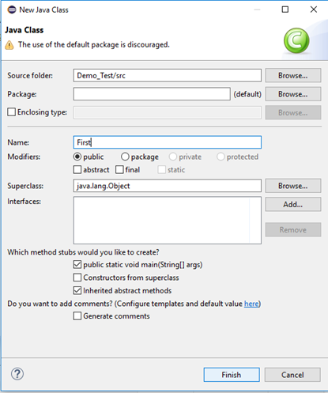

Now, we will add the Selenium jar files in our Test Suite (Demo_Test).

* Right click on "Demo_Test" folder and select Properties.

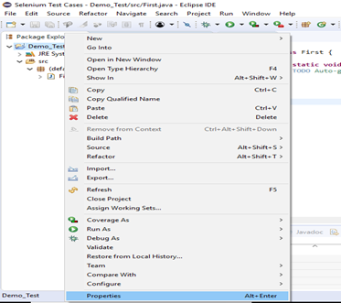

* It will launch the Properties window for our "Demo_Test" Test Suite.
* Click on "Java Build Path" option from the left hand side panel.

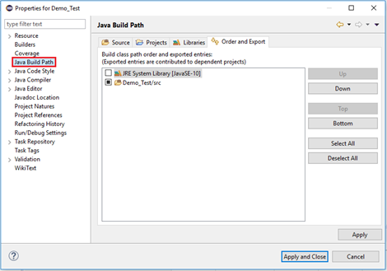

* Switch to Libraries tab and click on "Add External JARs" button.

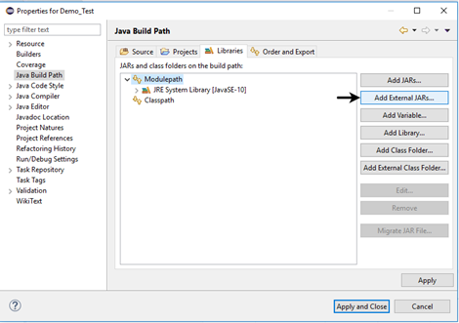

* Locate the directory where you have downloaded the Selenium jar files, select the respective jars and click on "Open" button.

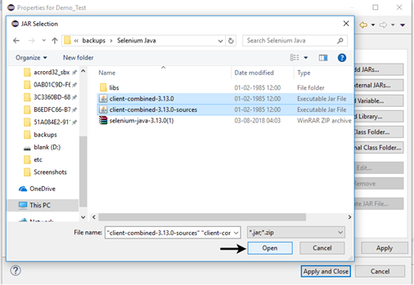

* Repeat the same steps for the jars which are present under the "libs" folder.
* Open "libs" folder, select all of the respective jar files and click on "Open" button.

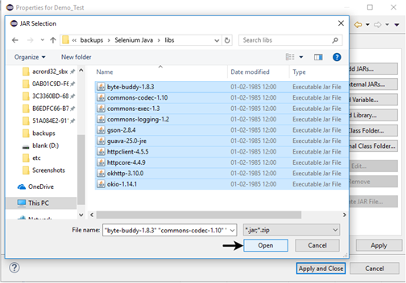

* Once you get all the Selenium jar files in your Libraries tab, click on Apply and Close button.
* The following image shows the directory structure of our "Demo_Test" test suite after adding Selenium jars.

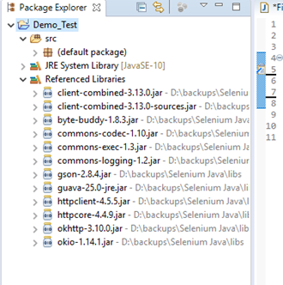

Hence, we have successfully configured Selenium WebDriver with Eclipse IDE. Now, we are ready to write our test scripts in Eclipse and run it in WebDriver.